10.45: Apply conservation of angular momentum 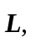with the axis at the nail. Let object A be the bug and object B be the bar.
Initially, all objects are at rest and 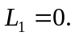
Just after the bug jumps, it has angular momentum in one direction of rotation and the bar is rotating with angular velocity 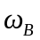in the opposite direction.
